Nathaniel Vanderpuye
Synch with Me: Synchrony, relationships and the aftermath
B.Sc. (Hons) Computer Science
7th February 2019

Declaration
I certify that the material contained in this dissertation is my own work and does not contain unreferenced or unacknowledged material. I also warrant that the above statement applies to the implementation of the project and all associated documentation. Regarding the electronically submitted version of this submitted work, I consent to this being stored electronically and copied for assessment purposes, including the School’s use of plagiarism detection systems in order to check the integrity of assessed work.
I agree to my dissertation being placed in the public domain, with my name explicitly included as the author of the work.
Date: March 2019
Signed:

Abstract
The goal of this project was to carry out research into the real-world applications of synchrony and how effective it can be in a social setting. To do this, this project explores the feasibility of using biofeedback to achieve physiological synchrony in two partners, and reports on any observed changes in each users state. The results of this project showed that even without using biofeedback to coerce synchrony to occur, a very simple implementation of a guided breathing application still has the potential to trigger some of the benefits of synchrony in individuals. A repository of working documents for this project, including source code and user study results, can be found at:
https://github.com/Lancsnv/Synchrony-application

Table of Contents
Declaration 2
Abstract 3
Chapter 1: Introduction 6
Chapter 2: Background 8
2.1. Biofeedback systems 8
2.2. Interpersonal synchrony 10
2.3. Emotion regulation 10
Chapter 3: System design and implementation 12
3.1. Analysis of biofeedback systems 12
3.1.1. Pause 12
3.1.2. Bright hearts 13
3.1.3. Breeze 14
3.1.4. Conclusions 15
3.2. System architecture 15
3.2.1. Activity design 15
3.2.2. System requirements 17
3.2.3. System mockups 18
3.2.4. System implementation 20
Testing and evaluation 29
Chapter 4: User Study 30
4.1. Methodology 30
Chapter 5: Summary and evaluation of results 32
5.1. Key findings 32
5.1.1. Overall analysis of the experience 32
5.1. 2. Analysis of the applications usability 32
5.2. Implications of the user study 33
Chapter 6: Conclusion and future work 34
Overall project aim review 34
Future Work/Improvements 34
Final remarks 35
Appendix 1. Project Proposal 39
Abstract 39
Coregulation background 39
The project 40
Project objectives 40
Project methodology 41
Project workplan 42
References 43
Appendix 2. Participant information sheet 45
Appendix 3. Consent form 48
Consent form 48
Appendix 4. User study interview questions 50
Initial interview questions 50
Second interview questions 51
Appendix 5. User study poster 52

Chapter 1: Introduction
Personal relationships hold a lot of value in our day to day lives, they provide a way for us to understand each other, vent and feel a sense of closeness with another person. Establishing deep bonds with people has very clear benefits, but something as small as having a disagreement can have long lasting detrimental effects. Having the ability to maintain these relationships and recover from setbacks is extremely important, and because of this, this project is centered around attempting to introduce synchrony into relationships.
Synchrony is the coordination of events to operate a system in unison [15], and as a process it’s relatively simple, but the positive aspects it can introduce after occurring is where the heart of this project lies.
The project “Synch with me: A mobile app to achieve breathing synchrony” explores interpersonal synchrony: specifically, the synchronization dynamics between the physiological activities of two or more individuals. Existing work explored interpersonal synchrony in various contexts and linked it to several relational features such as fostering empathy, attachment security, closeness, trust, cooperation and mutual affect regulation [22 -27].
Although physiological synchrony tends to happen quite naturally between human beings [16], the physiological signals are not directly observable and require an additional layer in order to become perceivable. The goal of the project is to support two or more users to achieve a state of physiological synchrony, by utilizing breathing biofeedback as an intermediary layer. Breathing was chosen as the form of biofeedback to use over other physiological measures, because of its innately manageable nature in comparison to other physiological measures, for example, heart rate variability, skin conductance or brain signals (EEG).
By doing this, I hope to further research into interpersonal synchrony, and expand on its real-world applications for developing healthier social relationships. If this project is successful, it may open new avenues to develop an understanding for individuals we otherwise may not appreciate.
This report is structured to include the following chapters:
Chapter 2 will be used to review previous research into the fields of biofeedback and interpersonal synchrony, and derive useful information that can be used during the development of this project.
Chapter 3 will be used to establish successful design goals and integrate them into the systems architecture during development.
Chapter 4 will be used to detail the methodology behind the user study and information gathering for the project.
Chapter 5 will be used to discuss the results received from the previous section and explore what implications they might have.
Chapter 6 will be used to discuss how well the project met it’s original aim, and discuss any further work that could be done to improve the progress made.

Chapter 2: Background
This section details and analyses past research regarding the relevant fields to this project, doing this establishes expectations and helps build a sound basis for later stages of design and implementation.

2.1. Biofeedback systems
Biofeedback is a process that’s usually overlooked, it enables us to gain more information about the simplicities of our day to day lives and is best described as the process of gaining a higher level of awareness of our most primitive physiological functions. Ways to integrate biofeedback are constantly being developed to help increase our awareness of what our bodies are going through, with the most popular integrations revolving around heart rate and electrodermal activity signals (EDA). The nature of biofeedback makes it very capable in representing information about health and other bodily functions [10]. This benefit makes it very useful in representing wellbeing, and as a result, ways to track this data are constantly being incorporated in various forms of technology [13]. The importance of the information provided by biofeedback has given it an opportunity to be integrated into multiple aspects of everyday life. Widely used smartphones [12], gadgets and applications [11][14] have all been refined to include biofeedback technologies. When used proactively, these devices can offer ways to premeditate against critical health events [28] or simply just provide a means for us to passively monitor our physical state (See Figure 2.1). An example of this is shown in figure 2.1 where the Samsung health application includes ways for users to receive feedback on their heart rate and stress levels. Along with this, when introduced into social scenarios, biofeedback has been observed to be valuable in helping the development of cooperation and trust [7]. Sharing information about our physiological state gives others more context into what we’re feeling and experiencing, and therefore enables them to acclimate their approach to us accordingly.

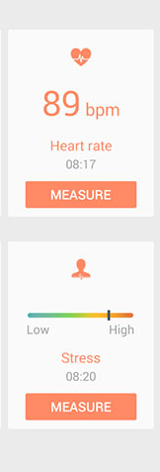
A substantial amount of research has been done into capturing and visualizing data centered around emotions, these technologies function by collecting longitudinal information about a person’s state of mind, and represent them in ways that can be interpreted for further application. An example of one of these technologies is AffectAura [31], it builds on a very popular framework around affect known as valence and arousal [38]. It utilizes multimodal sensors to gather audio, visual, physiological and contextual data from users in an effort to accurately predict a user’s affective state, these estimations are then represented on an interactive affect timeline which enables users to gain insight on their recorded emotional data. This technology also integrates the idea of using a very soft palette of shapes and colors in its interface design, with circles and cooler colors taking a much more prevalent role in order to maintain a soothing atmosphere during use.
Other technologies include Affective Diary [33] and Affective Health [32] which function by using vague representations to inform users about their emotional state, they utilize sensors to gather physiological information, and represent affective data in abstract manners that are left open to interpretation. This is done with a goal of enabling users to look back on their memories and reflect on their past constructive and undesirable behaviors to better themselves. AffectCam [34] is another visually centered piece of technology that focuses on exploring the benefits of using affective technologies longitudinally. It explores the idea of increasing the efficiency of high arousal memory recall in individuals that may suffer memory related impairments. This process uses three pieces of technology, AffectCam, SenseCam and SenseWear to capture images throughout a user’s day, capture their galvanic skin response via a sensor when an image is taken, and interpret the data at a later time to filter out the highest arousal photos. By accurately drawing out high arousal memories, the most notable moments of a user’s day can be brought to the forefront of their minds for further reflection.
Figure 2.1: Samsung health application being used on a gear fit 2

As is evident from the research, biofeedback is a field with multiple useful applications, these applications have been thoroughly explored but tend to be in the closed off setting of exploring an individual’s intrapersonal benefit. Most biofeedback apps are solely designed around solo use and are centered around providing a singular user with information about their biological state. This project builds on the idea of utilizing the benefits of biofeedback systems for interpersonal benefit, specifically by sharing biofeedback information with others in order to provide more context on what we’re physically experiencing, and let them know how we naturally react to forms of stimuli.

2.2. Interpersonal synchrony
Although carrying out the exact same actions as another person seems like an odd everyday occurrence, synchrony is a very potent mechanism with the potential to introduce a plethora of positive effects into relationships. Achieving synchrony has been seen to heighten feelings of generosity and self-sacrifice for others [24], improve self-categorization with others as a unit [17], aide in the development of feelings of closeness between individuals [18] [19], and have a positive influence on prosocial behavior [24].
Interpersonal physiological synchrony is often expressed through multiple modalities such as body movements, breathing patterns, skin conductance, heart rate and pupil dilation etc. For example, tapping a table at the same time as someone else has been observed to make them twice as likely to help you [30]. In-fact in some circumstances, interpersonal synchrony only requires individuals to be in close proximity to one another to occur. In a relatively recent paper, Palumbo et al. found that just sitting two individuals face to face, having them stare at each other, and asking them to refrain from communicating can still be enough to trigger a natural synchronous rhythm between them [30]. Interpersonal synchrony can occur between two individuals just from existing.
However, much like most other studies, variance can always be a wildcard that needs to be considered, this is especially true when exploring topics that have to do with physiological reactions, as they can vary wildly from one individual to another. It’s been observed that an individual’s affinity towards synchrony could lead to positive or negative emotions, these feelings elicited by synchrony can influence participants to take wildly different approaches to events, and skew results based on how they interpret the situation [20].

2.3. Emotion regulation
Emotion regulation is the ability to control an emotional response when faced with a form of stimuli, this is done to prevent certain emotions from dictating the response that’s eventually given [1]. Being able to control the stakes emotions have in our behavior can be very useful, especially when we’re required to stay objective or possibly dial back negative emotions like anger and frustration. Because of this, providing outlets for people to efficiently regulate their emotions and mood has been a growing area of interest over the past years, multiple approaches have been taken and developed such as mobile applications that can be used for brief periods of meditation [2][3][4] and virtual reality sandboxes that users can engorge themselves in to escape their negative emotions [5].
Active deep breathing has been a staple widespread method of regulating ourselves when we need emotional assistance the most, as a part of our culture we often take deep breaths to calm ourselves down in emotionally taxing situations. Using this strategy substantially speeds up the process regaining our composure.

Chapter 3: System design and implementation
This section explores the design decisions made during the development of the project, and focuses on the core principles applied in the systems design and implementation. It includes an analysis of current systems and looks to introduce observed areas of successful design into the application.

3.1. Analysis of biofeedback systems
Most of these biofeedback systems were developed in order to aid users in a variety of ways, mainly focusing on increasing the user’s awareness of their health or acting as an intermediary source of reducing stress. This section focuses on analyzing these pre-existing biofeedback systems and drawing ideas and techniques from them that can be utilized for the design of the mobile application.

3.1.1. Pause
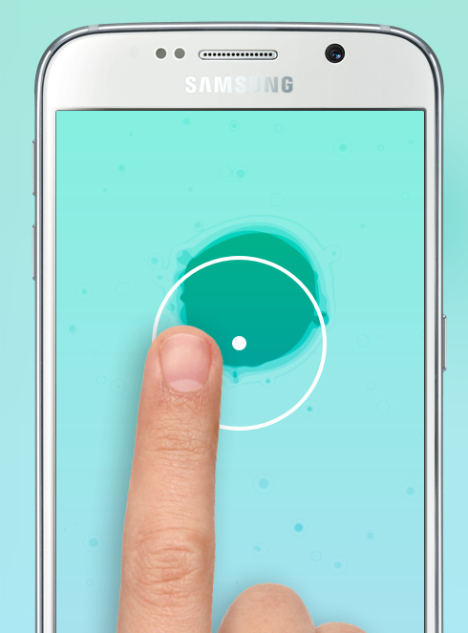
Pause is a biofeedback app available for use on a majority of android and apple devices, it is designed for intrapersonal use and concentrates on accommodating meditative therapy. It places more of an emphasis on providing users with a physically interactive experience, while still utilizing widespread strategies such as relaxing ambient sounds and a calming color pallet. It achieves this by focusing users on an objective of growing an undulating orb by following a circle with their fingertips (See figure 3.1), they are then given feedback when they move too fast or slow in order to help maintain a consistent steady rhythm of growth.
Figure 3.1: Pause application in use

The design choice of keeping the main activity simple works well since users get to divert their focus to completing a menial task while being surrounded by calming elements, this pairs well with the circular guide object which brings a sense of completion to the activity. Along with this, the application integrates a cool color pallet ranging from light blues and greens to purples, which helps maintain a laid-back environment and makes users feel at ease. The use of these features ties together to provide a relatively relaxing and inviting experience, and the application succeeds in fulfilling the goal it aims to achieve.

3.1.2. Bright hearts
BrightHearts is another intrapersonal biofeedback application that focuses on activating a rest and relaxation response in users, it utilizes a similar design strategy to PAUSE by including a circular shape as the centerpiece of its activity (See Figure 3.2). This circle mimics the heartbeat of a user by expanding and contracting to the rhythm of a heart rate sensor. The heart rate data is then processed and used to change the background color and audio being used during the activity, with lower pitch chimes and a red color being used to represent a faster heart rate, and higher pitch chimes and a blue color being used to represent a slower heart rate. A heart rate sound mimicking the heart rate of the user is also played in the background at a much more ominous low pitch throughout the activity.

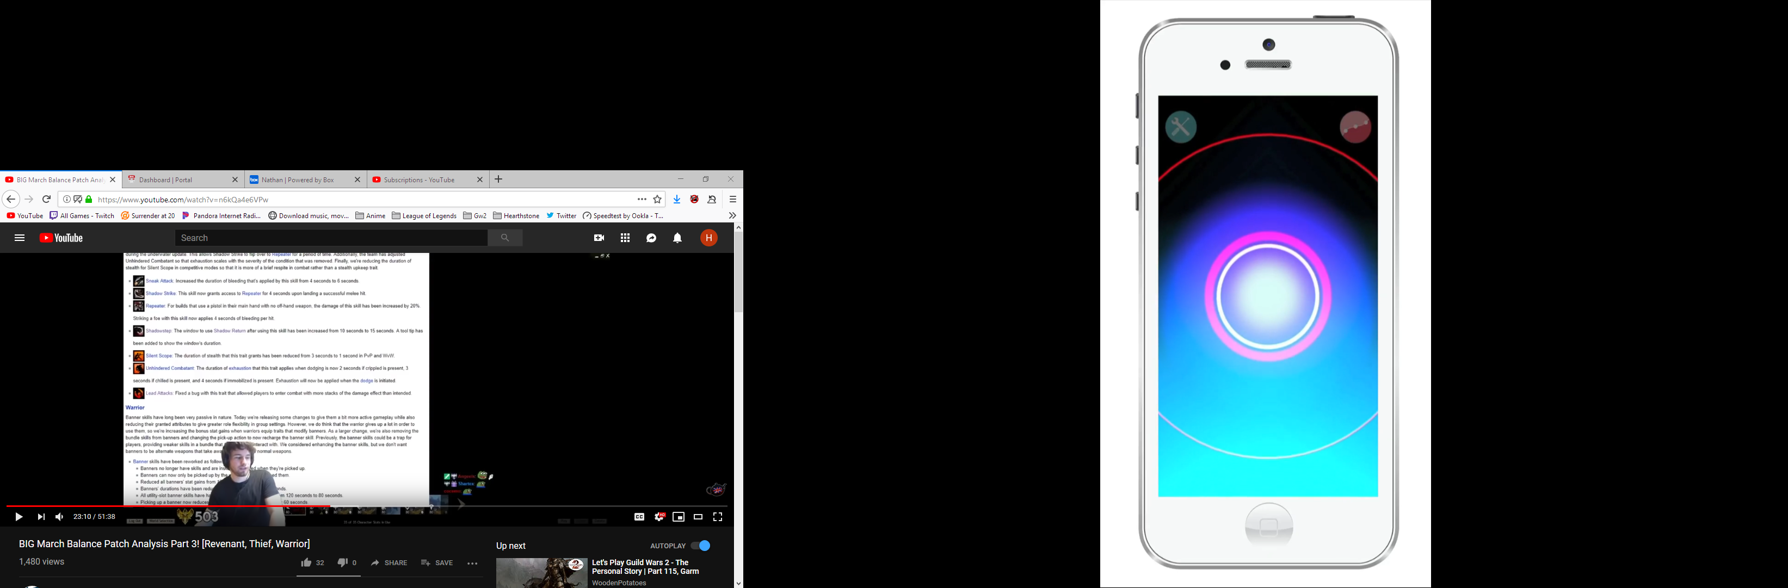
Figure 3.2: BrightHearts application in use

The use of a circular shape as the centerpiece of the activity helps retain a wholesome atmosphere, along with this, it also simulates the process a heart experiences during expansion and contraction which helps increase user awareness to the data being collected. The choice of audio feedback seems rather hit or miss in the app as the gaudy chimes and heart beat in the background feel too overbearing and anxiety inducing. The audio seems to detract from the overall goal of activating a relaxing response in users. However, the choice to use dynamic background colors during the activity seem to be quite effective at maintaining a relaxing environment, especially when paired with the more serene color pallet used throughout the application.

3.1.3. Breeze
Breeze is a biofeedback device that looks to benefit both intrapersonal and interpersonal communication, it collects physiological signals from a user and represents the data through 3 modalities; audio, visual and haptic changes. The device itself is a pendant that contains a sensor, this sensor collects breathing data and can be linked to a partner in order to receive feedback of their physiological state. Depending on a user’s physiological signals, the device fluctuates in brightness, vibration strength and plays pink noise at varying levels to represent the perceived situation (See figure 3.3).

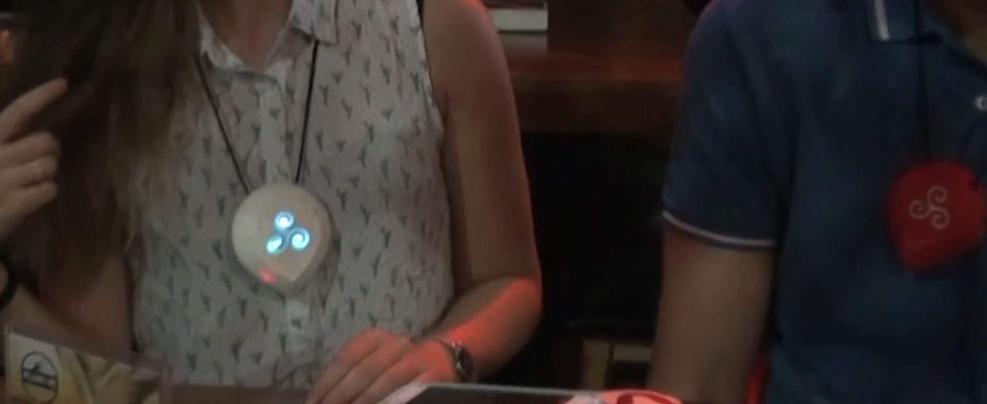
Figure 3.3: Breeze devices in use
The approach of displaying the biofeedback information of a user to their partner is extremely beneficial in this context. The feedback allows for users to recognize when their counterpart needs attention, and allows them to share time or console them when it matters the most. The use of audio seems impractical since users might not be in situations where audio is a feasible biofeedback method e.g. a library. However, using color brightness and vibration as forms of feedback seem perfect for fulfilling the aim of the device, both forms of feedback are very easy to notice when they occur and grab the attention of a user immediately, making them useful for sharing high arousal events between both partners, and making a user understand the current situation of their companion. The choice of breathing as a form of biofeedback seems relatively interesting, it opens room for intentional breathing patterns to be used as a communicative device between both individuals. This allows both individuals to use their breathing to get the attention of their partner, or possibly even help regulate them due to the controllable nature of breathing.

3.1.4. Conclusions
From analyzing these forms of biofeedback, breathing stood out to be the most suitable integration for the project. By placing breathing as the observed physiological function and method of feedback, users can self-regulate more easily in comparison to other forms of biofeedback and are enabled to have a more active contribution towards the overall goal of achieving a state of synchronous actions with their partner. The following design choices also stood out to be successful or experimental in a way that would benefit the system implementation:

- Implementing a relatively simple activity to allow users to focus on their partners feedback.
- Using a circular centerpiece object during the activity to represent the expansion and contraction of a user’s chest while breathing.
- Maintaining a serene and cool color pallet throughout the design to welcome and immerse users.
- Using unobtrusive or even possibly no audio feedback to prevent detracting from the main goal of achieving synchrony.

3.2. System architecture
Performing background analysis into biofeedback and relevant systems established new ideas for features that could be included in the prototype application. The following subsection is dedicated to explaining the decisions made regarding the systems structure.

3.2.1. Activity design
A very important observation was that the main activity would need to be simplistic and easy to partake in, overwhelming users has a tendency to draw attention away from tasks, and for this activity, retaining their focus is necessary to encourage more involvement towards achieving synchrony. To enforce this further, background audio is not being included in the app as it may be too distracting and intrusive while completing a session.
Because of the nature of actively achieving synchrony, the form of biofeedback used in the activity needs to be easily controllable. Breathing fulfils this criteria and compliments this project well. It also opens room for completing simultaneous rhythmic movements that allow users to achieve synchrony at a much higher rate [9]. Along with this, a circular representation for the breathing biofeedback would be an intuitive pairing because of the suitability of circular objects in representing expansion and contraction.
Planning for the implementation of the main activity requires a method of collecting breathing data from both users, processing it in real-time using the mobile application, and representing the data to both users during their activity session. To help derive the applications requirements the use case diagram shown in Figure 3.4 was developed.

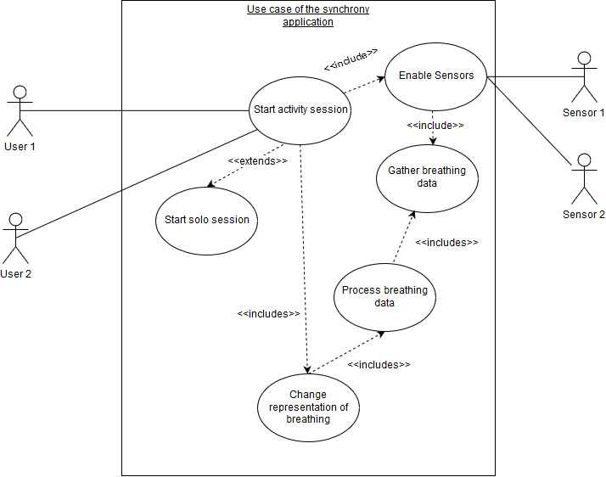

Figure 3.4: UML use case diagram for the synchrony application

3.2.2. System requirements

3.2.2.1 User Interface (UI) requirements
A large part of successful application design stems from having appropriate interface design goals, these goals increase the usability of the system and remove external factors from possibly detracting from the applications main intent. These UI design goals were distilled from analyzing applications in a similar field to this project, and using the Web Content Accessibility Guidelines (WCAG) to ensure important user centered goals are established [21].

Table 3.1: User Interface design requirements
ID | Design Goal
G1 | Maintain user comfort by making the application feel as human as possible during use.
G2 | Keep information as intelligible as possible by avoiding highly stylized fonts.
G3 | Maintain a WCAG AAA rated color contrast throughout the app to improve the readability of information and increase user accessibility.
G4 | Keep functionality consistent throughout the application to promote intuitive interaction.
G5 | Refrain from overwhelming users with information. Provide feedback and keep areas of focus free of clutter.
G6 | Make interactive elements large and intuitive to use in order to aide usability.
G7 | Remove the need of memory reliance to complete a task by adequately guiding users to the core focus of the application from the start of their experience.

3.2.2.2. Activity requirements
To help design the core functionality of the prototype, these system requirements were derived from analyzing current biofeedback technologies, consulting with my project supervisor and utilizing the use case diagram shown in Figure 3.4. These steps were taken in order to ensure that the implemented system fulfils the projects goals, and can act as a helpful intermediary for achieving synchrony between two individuals.
Table 3.2: Main Activity requirements
Functional Requirements
ID | Requirement
R1 | The application shall include an activity that can be completed by 2 users
R2 | The application shall be able to read breathing information gathered from a sensor
R3 | The application shall be able to represent gathered biofeedback data
R5 | The application shall allow users to select an activity session length
Non-Functional Requirements
ID | Requirement
NFR1 | The application shall adhere to the WCAG color contrast requirements
NFR2 | The application shall run on all android devices running API version 21 and above
NFR3 | The application shall take no longer than 2 minutes to start an activity session

3.2.3. System mockups

3.2.3.1. User interface(UI) mockups
These application mockups were created by following the established design goals in Table 3.1, and were designed to create a solid foundation for the user interface design of the application.
In this interface mockup, beneficial strategies and design choices from similar applications have been implemented in order to improve the ease of use and accessibility of the prototype. The interaction towards users has been kept laid back and inviting to establish a conversionary atmosphere, with the use of a softer font choice and AAA rated color contrast to increase the accessibility of the application. Along with this, the interactable objects throughout the application are sizable, and have been placed intuitively to grab the attention of users and lead them to start a new session. (See figures 3.5).
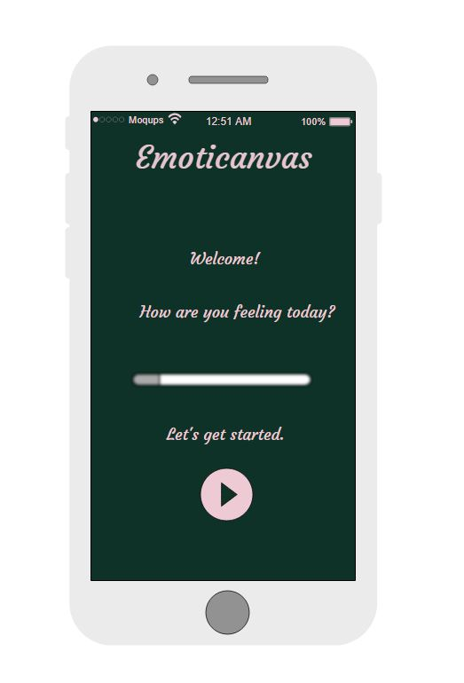
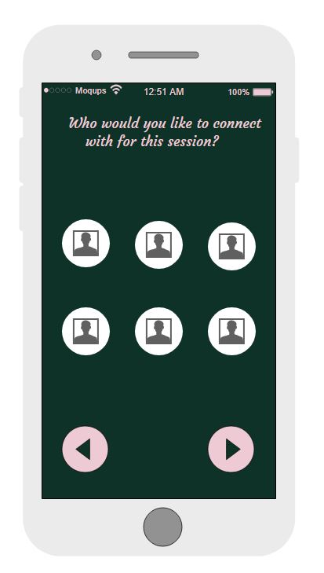
Figure 3.5 - Mock landing screen and partner selection screen interface

3.2.3.2. Activity implementation mockups
To form a cohesive main activity for the prototype, these implementation mockups were decided on from the derived application requirements shown in Table 3.2, and adhere to the UI requirements displayed in Table 3.1.
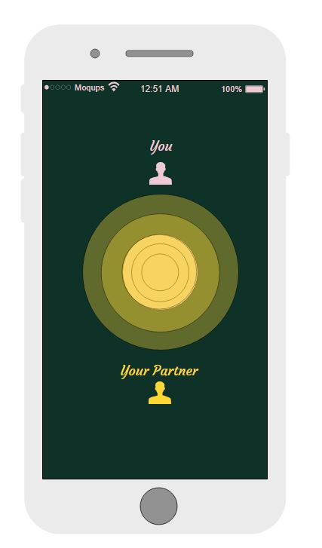
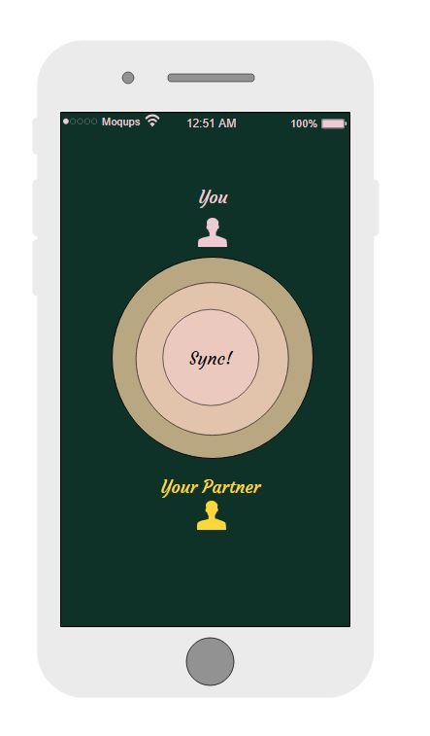
In this implementation mockup, the main activity has been kept relatively simple, with more emphasis being put on the representation of biofeedback provided to users. The circular objects are used as a centerpiece in a similar fashion to the analyzed applications, and are used to embody each users breathing, users are also allocated a circle of a specific color in order to help distinguish between the biofeedback from each participant. When both participants in a session have a desynced breathing pattern, the data from each of the sensors is used to effectively mimic their breathing pattern and maintain a desynced rate of growth for their corresponding circle. Whereas if a synchronized breathing pattern is accomplished, both circles establish the same rate of growth and visual feedback is provided to inform users that they have achieved a state of synchrony (See figure 3.6).
Figure 3.6 - Mock desynced and synced activity sessions

3.2.4. System implementation

3.2.4.1 Application development
Selecting an operating system for development was relatively easy as Android holds a large market share as the top mobile operating system, with 86.3% of smartphones in the world using the android framework over 13.2% using Apples iOS[35]. For developing the application, using a native approach was optimal as it guarantees a much higher degree of reliability, and boosts the performance substantially as the application is developed to run on one specific operating system.
The option to develop a web application was also available, meaning that any device with an internet browser could have access to the application, however doing that greatly increases the cost of performance, and would not be beneficial to compromise in as the application is centered on processing and representing data. This inevitably locks some users from being able to use the application, but a majority of the potential participants should most likely own android devices and be able to partake in the user study The choice of a development environment and language were also fairly straightforward as the official IDE for android, Android Studio, only supports the use of Java, Kotlin and C++. As Java was the only available language that we were practiced in, it was the only possible path to take for implementing the prototype.
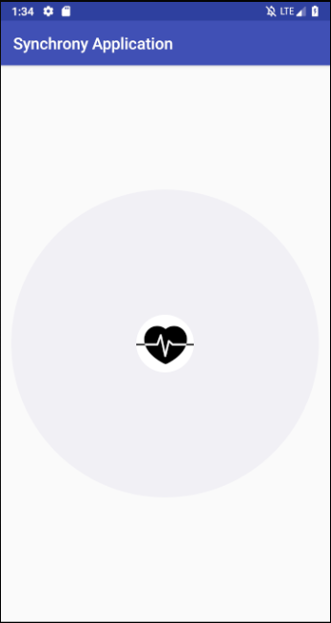
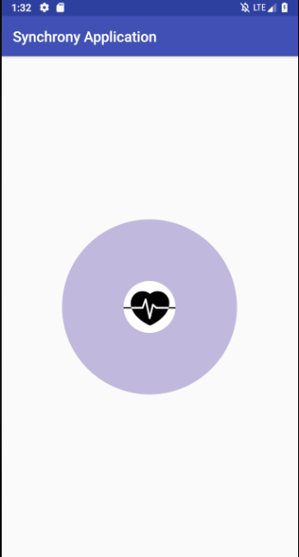
The first task at hand was to develop an activity implementation that could function with set parameters, this was done in order to develop a functioning prototype version that could later be fed sensor data. The first design utilized a preexisting library [36] to animate an expanding effect around a circle (See Figure 3.7), this implementation was only capable of providing an expanding effect, and did not portray the desired expansion and contraction effect to simulate breathing. Along with this, the increase in opacity as it expanded seemed detrimental, and could introduce usability issues for users with visual impairments.
Figure 3.7: Prototype v1 half and full circle expansion

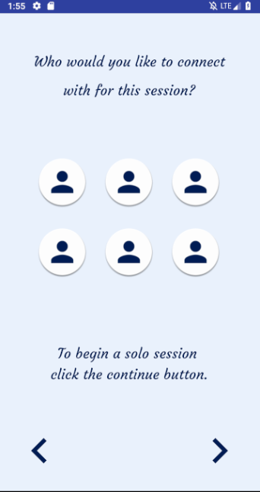
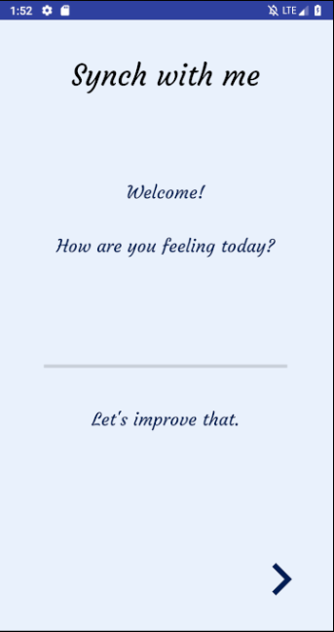
A second prototype version was developed from scratch to correct these downfalls, this prototype was developed using android studio animation xml files, and stuck much more closely to the design of the mockups created beforehand. This prototype version consisted of a landing screen to welcome users to the application, a partner selection screen that would allow users to select a partner for a session, and more suitable expansion and contraction animations for a single user’s circle (See figures 3.8 and 3.9).
Figure 3.8: Prototype v2 landing and partner selection screen

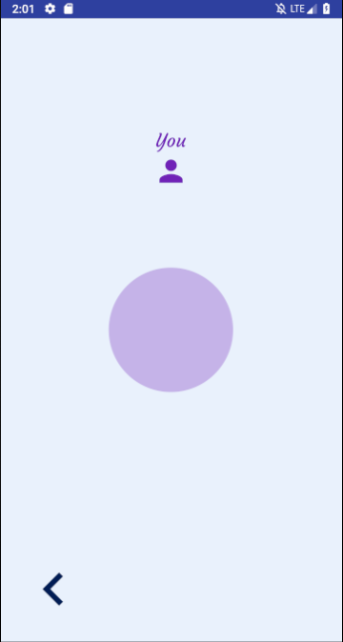
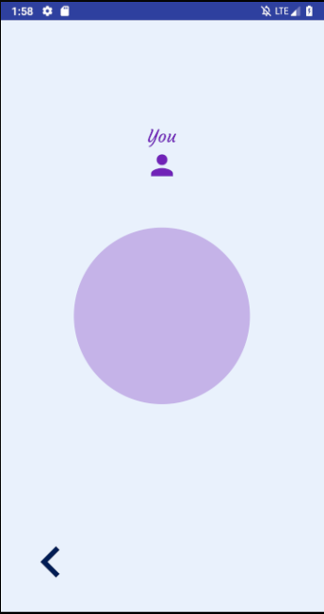
All of the screens in prototype version two consisted of navigation buttons that allowed users to traverse through the application, these were slightly revised in size and design compared to the mockup, since they were initially abit too large and took up too much screen space. The revised circle animation was achieved by developing a single xml file for the circle object, and calling a secondary animation file named Expand on the circle object once the session had begun to start the expansion and contraction process.
Figure 3.9: Prototype v2 half and full circle expansion

As prototype version two was in an acceptable state, prototype version three improved on it and included multi user functionality during one session (See Figure 3.10). This was accomplished by creating another circle for a partner, and then running a separate animation on it named minExpand that expanded at a different frequency.

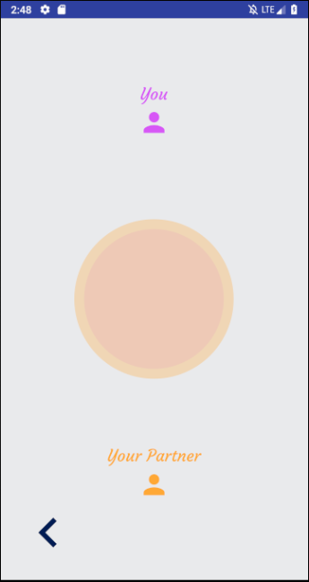
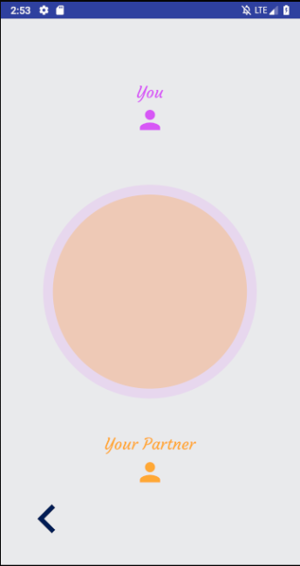
Figure 3.10: Prototype v3 main activity breathing overlap

At this version level, the application was ready for testing using real-time sensor data. An extra screen was added in prototype version four to allow users to configure their session length, and set the breath length for a full cycle of inhaling and exhaling (See Figure 3.11). This was done by using the setDuration method on the circle to set the animation length to be the selected time incremental, and setting an inbuilt timer to the user selected length which would inform users when it was complete.

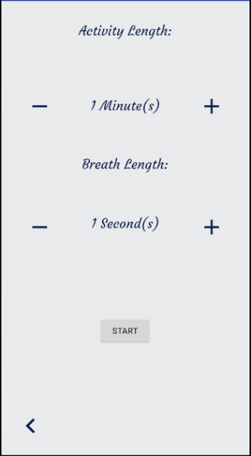
Figure 3.11: Prototype v4 session selection screen

3.2.4.2 Sensor integration
The second core task was to find an integrate an adequate respiratory sensor that could provide real-time results to the application. A respiratory sensor [39] developed by Plux was chosen for this task, the sensor used a localized sensing element to measure chest displacement caused by inhaling and exhaling, and would transmit raw data to a secondary BITalino board [40] that would need to be interpreted.
To enable the data to be transmitted wirelessly to a source device such as a user’s mobile phone, a third Plux device, R-IoT [41], was also required. This device functioned by using python to host a server and stream any data it received to an input destination address, a Li-Po battery was used to maintain portability and power the device.
Connecting the respiratory sensor to the BITalino board required both devices to be soldered and then connected to the R-IoT kit, we went through the soldering process and started working on connecting it to the R-IoT device (See Figure 3.12).
The R-IoT device required some pre-configuration to setup the serverBit that would receive the data, and specify the destination address, we went through this process and set the device up to transmit to a hotspot on our mobile devices named “riot” (See Figure 3.13).
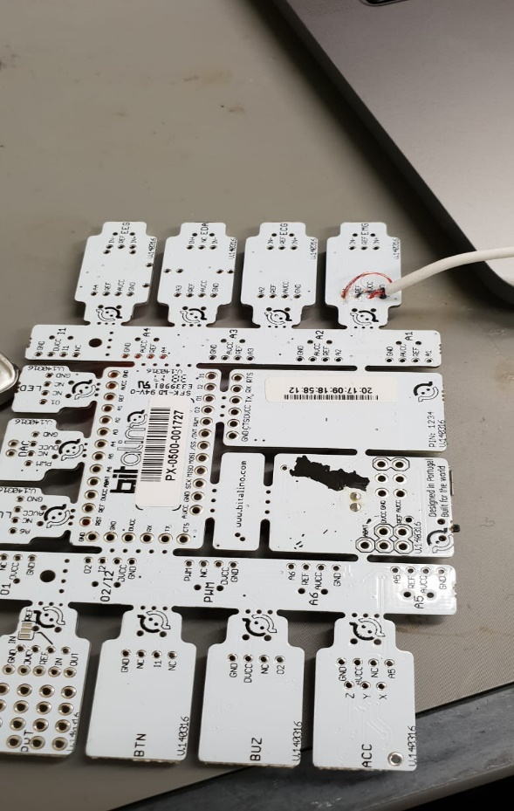
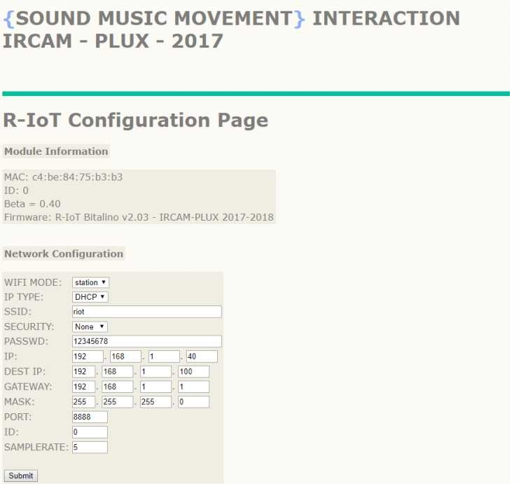
Figure 3.12: Soldered BITalino board and sensor
Figure 3.13: R-IoT device network configuration

At this stage, the R-IoT device started running into problems connecting to devices, multiple external devices were used to try and establish a connection but the server would not recognize any of them (See Figure 3.14). To remedy this, a line of communication was established with a developer who worked on the device to help correct any mistakes that could have been made during the connection process. After contacting the

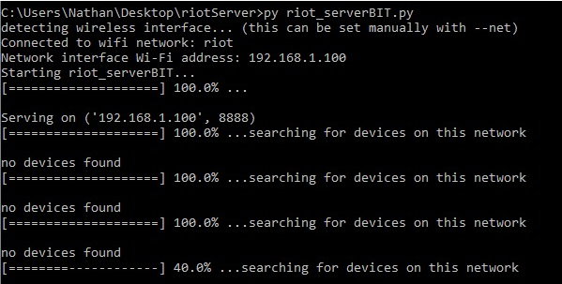
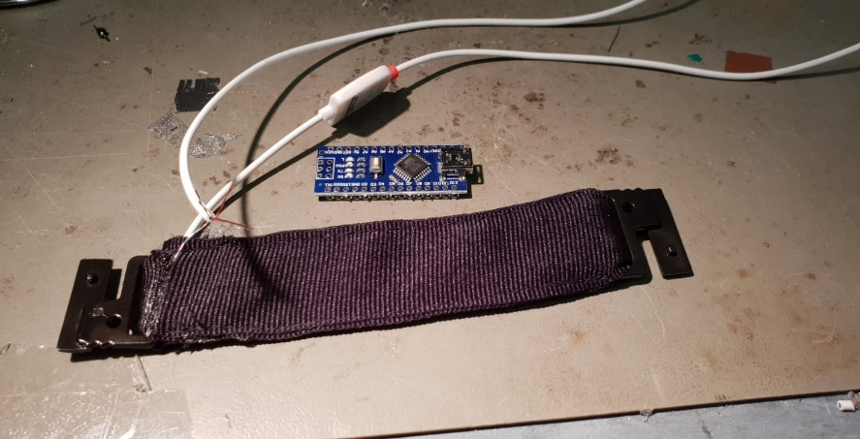
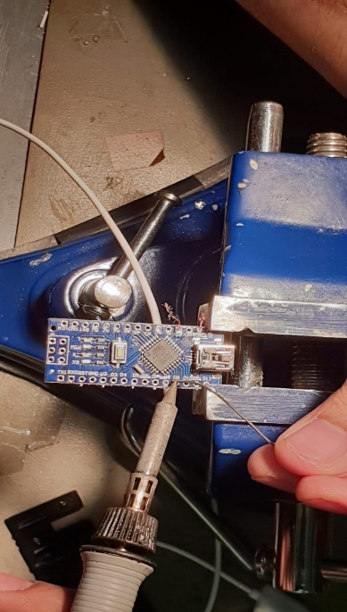
wdeveloper, an error on the server-side was brought to attention that was actively stopping devices from connecting to the server socket of the R-IoT kit. The problem was verified, but there was no time scope as to when the software issue would be resolved. Because of this, a revised plan was made to use an Arduino Nano to relay sensor data in place of the R-IoT kit. The sensor was then soldered onto the Arduino kit to start making progress on receiving useable data (See Figure 3.15).
Figure 3.14: R-IoT server connection issues

Figure 3.15: Soldering the sensor to the Arduino Nano board
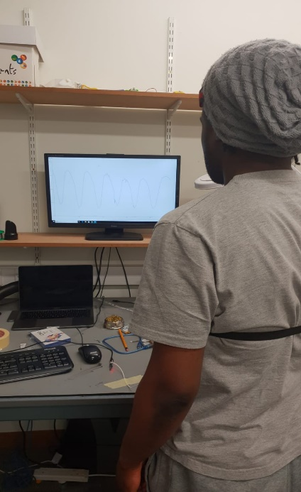
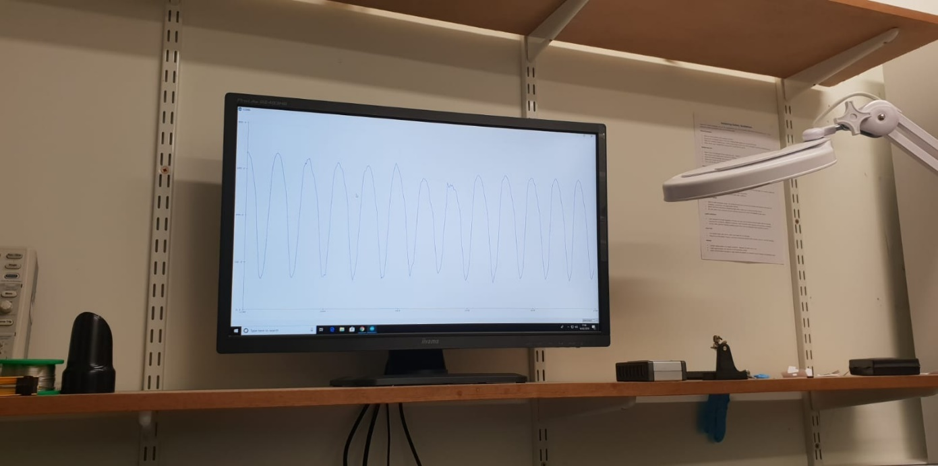
Once this had been done, the raw data being transmitted from the sensor had to be normalized using the provided algorithm to receive usable data that could be processed by the app. The following transfer function was used for data normalization: Displacement value in percentage = (Value sampled from the channel / 2^ n – ½) x 100 with n equaling the number of bits of the channel. After processing the data, the output of the sensor was observed and the device was functional, but the recorded data was experiencing high levels of noise and a sizeable time delay (See Figure 3.16). Due to projects reliance on accurate real-time data, the sensor could not be used in its current state, and further reconfiguring and processing of the device was no longer a possibility as a result of tight time constraints. To counteract this, a second revision of the implementation was decided upon to implement a system that could feasibly achieve the goals of the project within the time restriction.
Figure 3.16: Testing the normalized sensor output

3.2.4.1 Application revision
To accommodate for the loss of sensors in the project, the main activity in the application was reworked to function solely from one guiding circle that both participants could use, the idea being to stimulate synchrony from having users adhere to the rhythm of the application instead of one another.
In prototype version five, a majority of the application received an overhaul to fit the newly defined implementation goal. The background of all the screens in the application were changed to an animated gradient of colors, and the font used throughout the application was changed to the android default font Roboto.
The partner selection screen was replaced with a session selection screen, which included a choice to start a standard breathing pattern of 1.5 seconds of inhaling and exhaling [37] for 1 minute (See Figure 3.17), or create a custom session where they could specify an activity length and breath length (See Figure 3.18). The main activity was also amended to include one singular contracting and expanding circle that grew according to the selected breath length (See Figure 3.18).
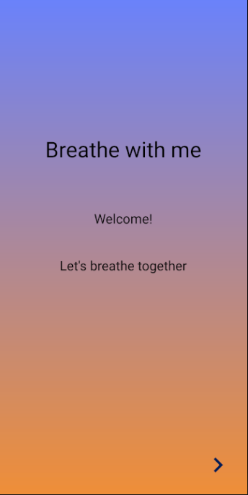
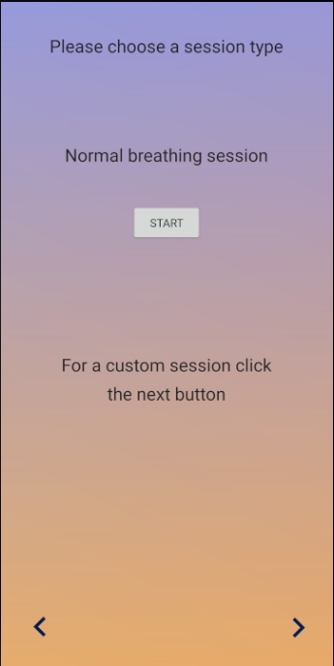
Figure 3.17: Prototype v5 landing and session selection screens

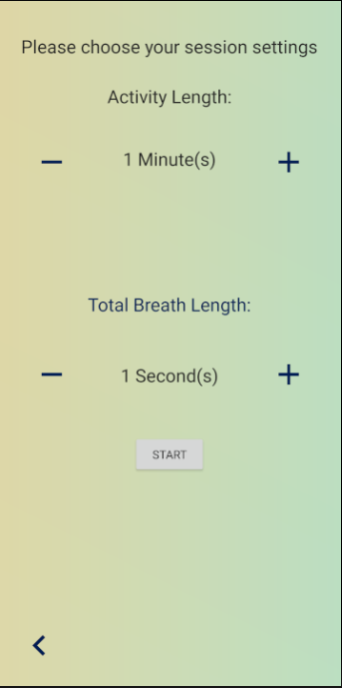
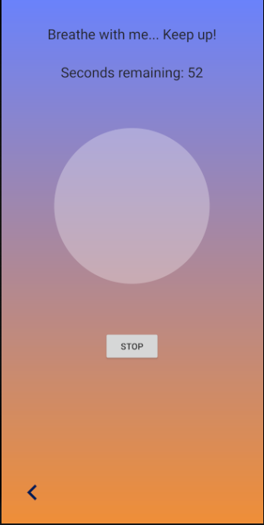
Figure 3.18: Prototype v5 session setting and main activity screens

Testing and evaluation
Due to the relatively simple nature of the final prototypes’ implementation, most of the bugs in code were ironed out through the development of multiple prototype versions. To verify this, a black-box system test was carried out by a postgraduate student who was able to start a custom session with selected parameters for an activity, and managed to start a preset normal session activity without any interference. The user study will also act as a third testing phase for the final prototype and feedback on the usability of the app will be gathered.

Chapter 4: User Study
In order to receive feedback on the overall user experience of the application, and gather information to detail its feasibility in meeting the goals of the project, a user study was undertaken to evaluate the effectiveness of the current system. This chapter covers the reasons behind each step of the methodology used for the study.

4.1. Methodology
The first task for the user study was to decide on how to test the prototype adequately. To receive feedback from users, there would need to be an initial interview after they completed the activity, an in-lab workshop would be adequate for achieving this. However, feedback could possibly be skewed by limited exposure and use of the app, and so the decision was made to have users complete the activity daily over 3 days after the initial in-lab workshop. This would allow for users to have more time to work towards achieving synchrony, and help cement their opinion on the system. To further this idea, much like in previous research [30], each session was made up of at least 15 minutes of completing the activity. During these 15 minutes users would be given an ample amount of time to start experiencing synchrony.
The second task was to recruit participants and introduce them to the idea of the project. This was done by placing posters (See appendix 5) throughout the spine on campus, and utilizing the SCC mailing list. Participants with breathing difficulties and chronic breathing problems were excluded from participating as they might have difficulty completing the activity, and users were required to apply in pairs as the activity was designed for the purposes of inducing interpersonal synchrony. Pairs of males and females between the ages of 20-50 were recruited to partake in the user’s study which lasted over 2 weeks, and each participant receive an £8 amazon voucher for their involvement.

In total, 6 participants consisting of 2 females and 4 males were recruited for the user study. Before the study began, participants were given a participant information sheet and asked to sign a consent form (See appendix 2 and 3). Participants were then given a codename to be referred to [P1 – P6], and all personal information except for their age, gender and emails were kept until the end of the project. After this was done, the application was explained to participants, and any questions they had about the project were answered. The in-lab workshop consisted of a 15-minute session using the application (See Figure 4.1), an interview after the session to collect feedback and a debrief of all participants. After three days, a brief second interview was held with participants to receive more feedback.
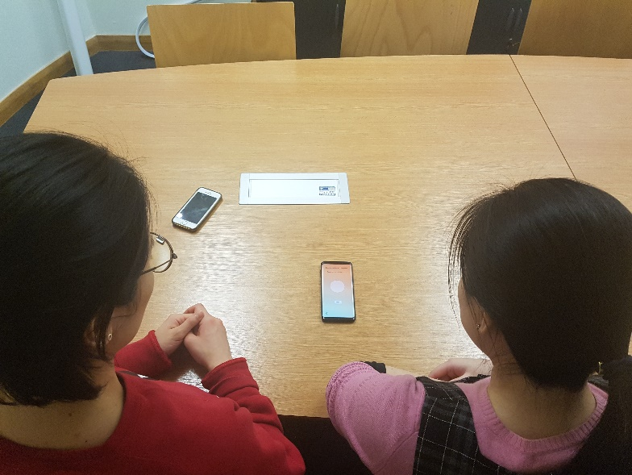
The data gathered during the interviews was recorded and transcribed, and can be found in the repository linked in the abstract.

Figure 4.1: Participants using the app during a workshop

Chapter 5: Summary and evaluation of results
This chapter reports on the key findings derived from interviewing the participants of the user study and analyzing the interview transcripts.

5.1. Key findings

5.1.1. Overall analysis of the experience
A majority of the participants voiced in the initial interview that they had a positive overall experience partaking in the user study, as it relaxed them and allowed them to get away from the pressures of life, participants 2 and 4 expressed, “…it’s nice to have that as the only thing to think about for 5 minutes” [P2], “…peace of mind, and I get some time to myself” [P4]. After three days, some participants voiced that they found value in being given a designated activity which allowed them to spend time together, with participant 1 saying, “…it was good to take time out of doing other stuff to do something specifically…” [P1], and participant 5 explaining, “It was beneficial in that I spent more time with my partner…” [P5]. Several participants voiced after the 3 days that completing the activity was beneficial to them, and they would be open to using it in select situations. Participant 5 said, “…If I met new people or if I had a date, I’d suggest doing this” [P5], Whereas participant 2 said, “Where I think it might come in useful is if I felt particularly stressed or anxious…” [P2].

5.1. 2. Analysis of the applications usability
Several users stated that the app was easy to use and navigate through when questioned about usability, with participant 2 saying, “That was good, that worked really well.” After the 3 day period the same sentiment was voiced again by participant 2 saying, “I think that’s a really simple thing to see and follow” [P2], and participant 1 saying, “I think it’s really easy to understand and makes perfect sense” [P1].
Almost all the participants stated that they appreciated the use of colors and a circle as a guide in the app, with participant 1 initially saying, “…The background colors were good as well” [P1], and participant 4 saying, “The animation and the timing were useful” [P4].
A relatively common viewpoint however, was that participants did not receive an adequate amount of feedback to let them know if they were breathing with their partner, half of the participants voiced that they were unsure about whether they were synchronizing or not, with participants 1,3 and 5 voicing, “…So, I’m synchronized with the phone but not necessarily with him.” [P1], “me and my partner could be out of sync at any time” [P3] and “I think I was more concentrated on my own breathing” [P5]. Whereas the other half said they were under the impression that their partner was breathing with them, participants 2,4 and 6 voiced, “But in my head, we were both breathing at the same time” [P2], “Relatively yeah, the animation helped keep us in sync” [P4], “But it’s nice you know, you hear someone breathing like you” [P6]. After the 3-day period, more users voiced that they would prefer having some way to track their partners breathing, participant 2 said, “It’s weird because it’s abit speculative but there is an increased awareness of your partners breathing…” [P2].
Some participants also voiced that they gradually became quite bored with the app over the 3 day period, and would like a more interactive experience, with participants 5 and 6 saying, “The first two days of the activity were boring since the 15 minutes felt really long…” [P5], and “…if the activity included more communicative things it might benefit interpersonal relationships a lot more” [P6]. There was also a noticeable demand for some sort of media after using the application for 3 days with participant 2 saying, “…I think there could afford to be some more media…” [P2].

5.2. Implications of the user study
Conducting a user study was a very useful tool for judging the general reception for the idea behind the project and its implementation. The user study pointed out multiple successes and failures in the implementation of the project that otherwise would not be easily recognizable. There were some obvious successes, such as the mostly positive reaction towards the use of a dynamic gradient background, and the use of animations to signify chest expansion and contraction. However, there was an overwhelming need that only increased over time for users to have more information about their partners breathing pattern. The importance of sensor integration for the project was too essential and the final product did not live up to the initial goals of the project. Nevertheless, the final prototype was able to allow for the collection of some useful feedback that could be of some use. The application was seemingly capable of getting users to pay more attention to the actions of their partners, and some participants even suggested that they would be open to using the current prototype in a more intimate setting, which suggests that they experienced some sort of closeness with their partner during the study. The simplistic and menial nature of the activity was also very calming for many of the participants, though there were some users that wanted to have a more active and physical experience with their partner. It was also voiced that after the 3-day period the application became relatively boring to complete, and could do with another form of stimuli such as more media. A decent compromise could probably be formed by increasing the complexity of the activity slightly in order to stimulate users to a higher level, or maybe even the inclusion of some unobtrusive background music.

Chapter 6: Conclusion and future work
This chapter reflects on the implementation of the entire project and reviews whether the aims of the initial project have been met. In addition to this, the chapter includes suggestions on how to improve the current project for future work.

Overall project aim review
The overarching goal of this project was to carry out research into the real-world applications of synchrony and how effective it can be in a social setting, and to an extent, I think this goal was met. Before starting this project, I was completely unaware of the byproducts of achieving synchrony and how useful they could be in a real-world setting. I gained the required knowledge to develop a prototype application that has shown promise in helping users to experience the beneficial effects of synchrony, and I am now relatively confident in my knowledge to implement activities with potential to elicit synchrony.
However, there were several downfalls during the project, especially in the implementation stage. The secondary goal of utilizing breathing biofeedback to support two or more users in achieving a state of physiological synchrony, was only partly met. The final prototype system did not utilize the breathing biofeedback of users, and instead attempted to elicit synchrony between users by having them complete an activity at the same time. Sensors were not integrated into the project as initially intended, and this was due to a mix of problems, including limited knowledge in engineering, and the projects time constraints.
Despite these circumstances, I still believe the project has some real-world potential and was fruitful in providing feedback for systems wishing to aide users in achieving synchrony.

Future Work/Improvements
The user study for the prototype brought many improvements to light and there are multiple areas of the project that could be enhanced to operate at a much higher standard.
Firstly, guaranteeing sensor integration for the app is most definitely the core improvement point to work on, having sensors for the activity allows for another level of interactivity and intimacy for all participants involved in the project. Proper implementation of sensors would most likely remove the need to include extra forms of stimuli such as audio, and increase levels of interest in users as it opens the door to the application being used in various contexts e.g. while users are in separate locations and want to reconnect with one another. Background research into biofeedback has shown that it has serious potential to increase the possibility of achieving synchrony.

As shown in the user study, some extra elements could be added to appeal to users that demand more incentives to retain their attention. Experimenting with introducing new animations, or unintrusive background music could be a beneficial way of doing this and definitely deserves some attention.

Final remarks
To conclude this section, I would like to mention that even though this project did not function in the exact way I initially intended it to, I still enjoyed the process and learned some valuable lessons on how to carry out the implementation of a solo project. Namely, researching for important facets of information that could be utilized to better an end product. The project was definitely stress inducing but help build on my adaptability and ability to form something useful out of failure.

References
[1]“Emotion Regulation.” Psychology Today, Sussex Publishers, www.psychologytoday.com/us/basics/emotion-regulation.
[2] Breathe with Me. leejones.ca/post/167469449551/breathe-with-me.
[3] “Mobile Application of Meditation & Relaxation.” Pause, www.pause-app.org/en/..
[4]“BrightHearts Research.” George Khut, www.georgekhut.com/portfolio/brighthearts-research/.
[5] Riva, Giuseppe, et al. “Affective Interactions Using Virtual Reality: The Link between Presence and Emotions.” CyberPsychology & Behavior, vol. 10, no. 1, 2007, pp. 45–56., doi:10.1089/cpb.2006.9993.
[6] Chanel, Guillaume, and Christian Mühl. “Connecting Brains and Bodies: Applying Physiological Computing to Support Social Interaction.” Interacting with Computers, vol. 27, no. 5, 2015, pp. 534–550., doi:10.1093/iwc/iwv013.
[7] Merrill, Nick, and Coye Cheshire. “Trust Your Heart.” Proceedings of the 2017 ACM Conference on Computer Supported Cooperative Work and Social Computing - CSCW 17, 2017, doi:10.1145/2998181.2998286.
[8] Marshall, Joe, et al. “Breath Control of Amusement Rides.” Proceedings of the 2011 Annual Conference on Human Factors in Computing Systems - CHI 11, 2011, doi:10.1145/1978942.1978955.
[9] Keller, P. E., et al. “Rhythm in Joint Action: Psychological and Neurophysiological Mechanisms for Real-Time Interpersonal Coordination.” Philosophical Transactions of the Royal Society B: Biological Sciences, vol. 369, no. 1658, 2014, pp. 20130394–20130394., doi:10.1098/rstb.2013.0394.
[10] Achten, Juul, and Asker E Jeukendrup. “Heart Rate Monitoring.” Sports Medicine, vol. 33, no. 7, 2003, pp. 517–538., doi:10.2165/00007256-200333070-00004.
[11] “Samsung-Health.” Samsung Electronics America, www.samsung.com/us/samsung-health/.
[12]“List of All True Heart Rate Sensor Enabled Phones.” WebCusp.Com - Make Living with Blogging and No Coding Web Design, 19 Aug. 2018, webcusp.com/heart-rate-monitor-phones/.
[13] Poh, Ming-Zher, et al. “A Wearable Sensor for Unobtrusive, Long-Term Assessment of Electrodermal Activity.” IEEE Transactions on Biomedical Engineering, vol. 57, no. 5, 2010, pp. 1243–1252., doi:10.1109/tbme.2009.2038487.
[14] “IOS - Health.” Apple, www.apple.com/ios/health/.
[15] M.S., Pam. “What Is Synchrony? Definition of Synchrony (Psychology Dictionary).” Psychology Dictionary, 25 June 2015, psychologydictionary.org/synchrony/.
[16] Palumbo, Richard V., et al. “Interpersonal Autonomic Physiology: A Systematic Review of the Literature.” Personality and Social Psychology Review, vol. 21, no. 2, 2016, pp. 99–141., doi:10.1177/1088868316628405.
[17] Páez, Dario, and Bernard Rimé. “Collective Emotional Gatherings.” Collective Emotions, 2014, pp. 204–216., doi:10.1093/acprof:oso/9780199659180.003.0014.
[18] Valdesolo, Piercarlo, and David Desteno. “Synchrony and the Social Tuning of Compassion.” Emotion, vol. 11, no. 2, 2011, pp. 262–266., doi:10.1037/a0021302.
[19] Kühn, Simone, et al. “Neural Correlates of Emotional Synchrony.” Social Cognitive and Affective Neuroscience, vol. 6, no. 3, 2010, pp. 368–374., doi:10.1093/scan/nsq044.
[20] Rafaeli, Eshkol, et al. “Affective Synchrony: Individual Differences in Mixed Emotions.” Personality and Social Psychology Bulletin, vol. 33, no. 7, 2007, pp. 915–932., doi:10.1177/0146167207301009.
[21] “WCAG 2.0 Checklist - a Free and Simple Guide to WCAG 2.0.” Wuhcag, www.wuhcag.com/wcag-checklist/.
[22] Marci, Carl D., et al. “Physiologic Correlates of Perceived Therapist Empathy and Social-Emotional Process During Psychotherapy.” The Journal of Nervous and Mental Disease, vol. 195, no. 2, 2007, pp. 103–111., doi:10.1097/01.nmd.0000253731.71025.fc.
[23] Diamond, Lisa M., et al. “Every Time You Go Away: Changes in Affect, Behavior, and Physiology Associated with Travel-Related Separations from Romantic Partners.” Journal of Personality and Social Psychology, vol. 95, no. 2, 2008, pp. 385–403., doi:10.1037/0022-3514.95.2.385.
[24] Wiltermuth, Scott S., and Chip Heath. “Synchrony and Cooperation.” Psychological Science, vol. 20, no. 1, 2009, pp. 1–5., doi:10.1111/j.1467-9280.2008.02253.x.
[25] Reddish, Paul, et al. “Let’s Dance Together: Synchrony, Shared Intentionality and Cooperation.” PLoS ONE, vol. 8, no. 8, 2013, doi:10.1371/journal.pone.0071182.
[26] Troxel, Wendy M. “Comment: Butler and Randall’s ‘Emotional Coregulation in Close Relationships.’” Emotion Review, vol. 5, no. 2, 2013, pp. 211–212., doi:10.1177/1754073912451631.
[27] Field, Tiffany. “Relationships as Regulators.” Psychology, vol. 03, no. 06, 2012, pp. 467–479., doi:10.4236/psych.2012.36066.
[28] Spire Health. “Clinical-Grade Health Monitoring and Insights.” Spire Health, spirehealth.com/.
[29] Frey, Jérémy, et al. “Breeze.” Proceedings of the 2018 CHI Conference on Human Factors in Computing Systems - CHI 18, 2018, doi:10.1145/3173574.3174219.
[30] Baer, Drake. “People Naturally Sync Their Bodies, Breathing - and Skin.” The Cut, The Cut, 31 Jan. 2017, www.thecut.com/2017/01/how-interpersonal-synchrony-works.html.
[31] Mcduff, Daniel, et al. “AffectAura.” Proceedings of the 2012 ACM Annual Conference on Human Factors in Computing Systems - CHI 12, 2012, doi:10.1145/2207676.2208525.
[32] Ferreira, Pedro, et al. “License to Chill!” Proceedings of the 5th Nordic Conference on Human-Computer Interaction Building Bridges - NordiCHI 08, 2008, doi:10.1145/1463160.1463174.
[33] Lindström, Madelene, et al. “Affective Diary.” CHI 06 Extended Abstracts on Human Factors in Computing Systems - CHI EA 06, 2006, doi:10.1145/1125451.1125649.
[34] Sas, Corina, et al. “AffectCam.” CHI 13 Extended Abstracts on Human Factors in Computing Systems on - CHI EA 13, 2013, doi:10.1145/2468356.2468542.
[35] “Smartphone Market Share - OS.” IDC, www.idc.com/promo/smartphone-market-share/os.
[36] Booncol. “Booncol/Pulsator4Droid.” GitHub, 17 Sept. 2016, github.com/booncol/Pulsator4Droid.
[37] “Normal Respiratory Frequency, Volume, Chart, ...” Normal Respiratory Rate, Volume, Breathing Chart, ..., www.normalbreathing.com/index-nb.php.
[38] Posner, Jonathan, et al. “The Circumplex Model of Affect: An Integrative Approach to Affective Neuroscience, Cognitive Development, and Psychopathology.” Development and Psychopathology, vol. 17, no. 03, 2005, doi:10.1017/s0954579405050340.
[39] “Respiration (PZT) Sensor.” PLUX Store, store.plux.info/barebone-sensors/40-respiration-pzt-sensor.html
[40] “BITalino (r)Evolution Board Kit BT.” PLUX Store, store.plux.info/kits/33-bitalino-revolution-board-bt-810121001.html.
[41] “BITalino R-IoT.” PLUX Store, store.plux.info/kits/376-bitalino-r-iot-810121007.html.

Appendix 1. Project Proposal
THE EMOTIONAL EFFECTS OF COREGULATION

Abstract
This project will be a study into emotional coregulation and the effects it can have an individual’s emotional state when applied.
The project will require an application to be created that employs a coregulation technique and gathers the heart rate from 2 users while they complete an activity. This information will then be fed back into the program and used for further coregulation of both user’s emotional state. During this activity their emotional states will be monitored and the effects of participating in the coregulation task will be displayed by the program once the task is complete.
The results of this project can then be used to look at the real-world applications of coregulation and how effective it can be in a social setting.

Coregulation background
Coregulation is a psychological term used describe the ability of an individual to modify the actions or state of another individual, this can be done through many different means but is a gradual and continuous change in one individual due to the continuous actions of another [1]. The topic itself has a lot of interest around it and has been researched extensively through history but a consensus on its application outside of childhood have not been agreed on by scholars. This project has to do with a subbranch of coregulation known as interpersonal emotion regulation which has to do with the use of coregulation to affect the feelings others [2], this is also known as emotional coregulation.
Some background into articles that investigated emotional coregulation, and the correlation between emotions and their effects on social relationships are included below.
- This extract looked at various methods, namely synchrony and mimicry which are theorized to help achieve emotional coregulation and analysed the results of studies where they were applied. Both methods are suggested to work because they allow an observer to activate the same neuron systems that another person uses during an action. This makes it much easier for the observer to recreate the action with ease. From the results of the studies we can see that mimicry and behavioural matching seem to have a positive coregulation effect because they achieve the effect of physically putting one individual in another’s shoes. By doing this participants tend to understand others' actions and in turn feel like they can affiliate with them more. Implementing one of these methods for the project through an activity on a mobile application could be adequate for coregulation testing, however if implemented results would be very dependant on data being read from an external source during the activity, and the application would have to be able to continually process the data and dynamically adapt depending on its input.
- This article aimed to try and further the knowledge about emotional regulation when applied in a social setting, the research was heavily driven by looking at the use of emotional regulation to improve relationships and improve the efficiency of individuals. It suggested that emotional coregulation is linked to our physiological allostatic balance which optimizes our performance and reduces costs when changes occur, some backing evidence for this in parent-infant relationships was presented which seemed suitable, however this project will act as an extension into the research of how emotional coregulation affects adults and whether coregulation can achieve the same optimization when applied in relationships involving two adults.
- Another project that looked at emotional self-regulation and how emotional states can be altered using a regulation activity, this project featured an application [6] that helped children focus their attention away from their anxiety and fear. This project is intended to expand on this implementation idea by using an application between two adult users for emotional coregulation.

The project

Project objectives
The main purpose of the project is to carry out research into coregulation and find out what aspects of real life it can affect when implemented. Specifically, whether it can be used to benefit social relationships and interactions between individuals. For the project to successfully be implemented these listed aspects will need to be completed and developed on:
- Further research into coregulation to discover methods that can be applied in a real-life setting and tested between two individuals. These methods will need to conform to the university’s guideline on ethics and have some credible background to their implementation i.e. studies where they are tested.
- An Android application with an adequate implementation of a coregulation activity will need to be created that can be used by participants of the project, this application will be required to process data received from an external sensor connected to each participant.
- After the coregulation activity has been undertaken user feedback should be gathered regarding their experience using the application, and how it can be improved along with details on what effect each user felt participating in the activity had on them.
- Both the data used by the program and the user feedback should be analysed to try and find a correlation between participating in the activity and a change in the user’s mental state. Further details on how this analysis will be carried out will be detailed in the project analysis section below.

Project methodology
The Project will be focused around a linear case study where 3-5 users participate in a coregulation activity presented on an android app, all users will be required to fill out an ethics form and agree to be part of the study as their personal data will be collected and used during the activity. This data will only consist of the heartbeat of each individual user which will be collected by a heartbeat sensor.
For the project, an application that implements a chosen coregulation activity will need to be created. This application will have the capability to use data gathered about a user’s emotional state and utilize it during the activity to help regulate another individual’s emotional state. The development of this application will include a design selection stage, implementation stage and a feedback stage. As the entire case study is rooted on the emotional state of end users, the design of the application will be user centred to make the activity as intuitive as possible and avoid emotionally influencing participants.
The feedback stage will be undertaken once the application is implemented where 2-3 more users will provide feedback on the application and help test the implementation for any bugs or flaws. This will help fine tune the activity to be as intuitive for end users and help remove any potential incidents that might affect the result of the study.
Once these stages are complete the application will be provided to the end users who will partake in the activity, after this users will be interviewed for 10 – 20 minutes where they ‘ll discuss their experience while completing the activity and answer a few questions on how they felt their emotional state had been impacted. The information given during these interviews will then be paired to the information gathered during the activity and analysed for the final project paper.
The structure of the project from start to end has been listed below in the project workplan section along with estimates of how long each task will take to complete.

Project workplan
This project will be undertaken near the end of October 2018 and will continue until the end of March 2019. The workplan for the project is listed below in chronological order:
- Coregulation activity selection – This will consist of some light research into co-regulation activity implementations and selection of an activity to implement for the application after evaluations. This should take 2 weeks.
- Application development – This will consist of 3 stages. A design selection phase where multiple designs will be explored for the application and the most adequate one will be chosen to implement the activity. A coding phase where the backend of the program will be implemented according to the design chosen in the former phase. And finally, a testing phase where the program will undergo various forms of testing to remove bugs and flaws and make sure it functions adequately for end users. This should take 4 weeks.
- Feedback stage – This will consist of gathering 2-3 users and asking them to attempt to use the application to complete an activity, these users will then be prompted to share any concerns or qualms they have with the implementation and the feedback will then be gathered and analysed. This should take 1 week.
- Application adjustment stage – During this stage the application will be adjusted to include priority changes gathered from the first feedback stage. Any bugs, errors and malfunctions of the program will be fixed, and some new features may be implemented. This should take 2-3 weeks.
- End User rollout – At this stage of the project the application will be ready for end users to utilize; 3-5 end users will be gathered and prompted to complete the activity using the application, the data gathered and used by the app during the activity will be compiled along with data from interviews with each user. This should take 2 weeks.
- Data analysis and Evaluation – During this stage the data collected from the end user studies will be analysed to find any correlations between the completion of the coregulation activity and a gradual emotional change of each user. The results of the analysis will then be evaluated and a conclusion on whether coregulation can be a viable method to regulate social relationships will be decided on, a discussion on the larger scale potential of coregulation will also be addressed according to the conclusion drawn. This should take 4 weeks.
The Gantt chart in the figure below demonstrates how the workplan will be implemented over the period of the project (See Figures 1 and 2).
FIGURE 1
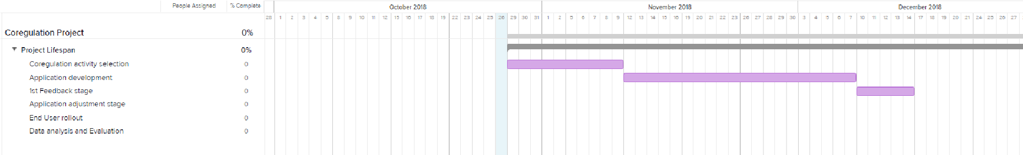

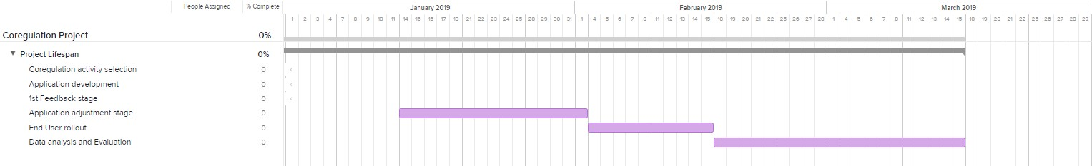
FIGURE 2

References
- Wikipedia. (2007). Coregulation. Wikipedia. Available at: https://en.wikipedia.org/wiki/Co-regulation
- Wikipedia. (2013). Interpersonal emotion regulation. Wikipedia. Available at:
https://en.wikipedia.org/w/index.php?title=Interpersonal_emotion_regulation&oldid=862528124
- Michael J. Hove and Jane L. Risen. (2009). Synchrony increases affiliation. pp. 949–961
- Butler, Emily & Randall, AK. (2012). Emotional Coregulation in Close Relationships. Emotion Review. 5.
pp. 202-210.
- George P. Khut and Angie Morrow. (2011). BrightHearts Research. Available at:
http://www.georgekhut.com/portfolio/brighthearts-research/
- George P. Khut. (2018). BrightHearts Heart Rate Biofeedback app for MIO pulse sensors and iOS. Available at: https://vimeo.com/279153077

Appendix 2. Participant information sheet

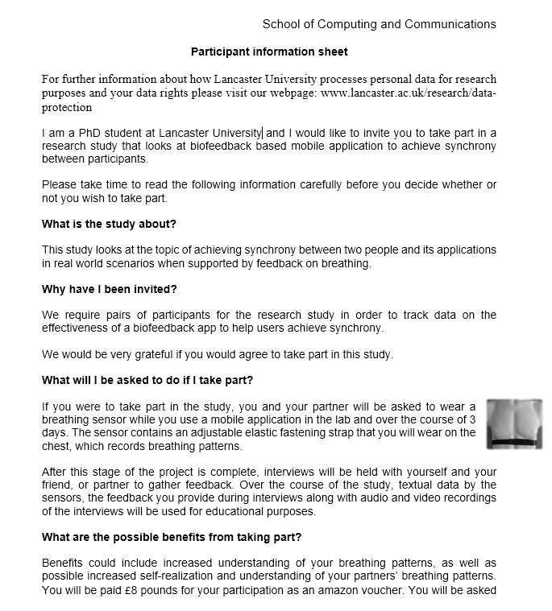

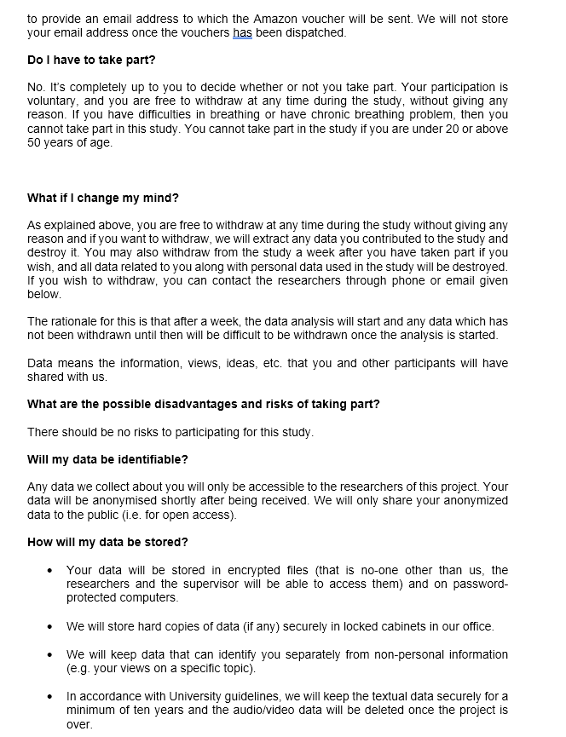
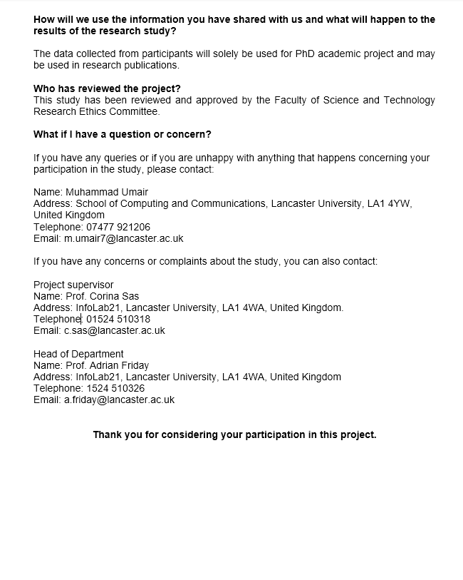

Appendix 3. Consent form

Consent form

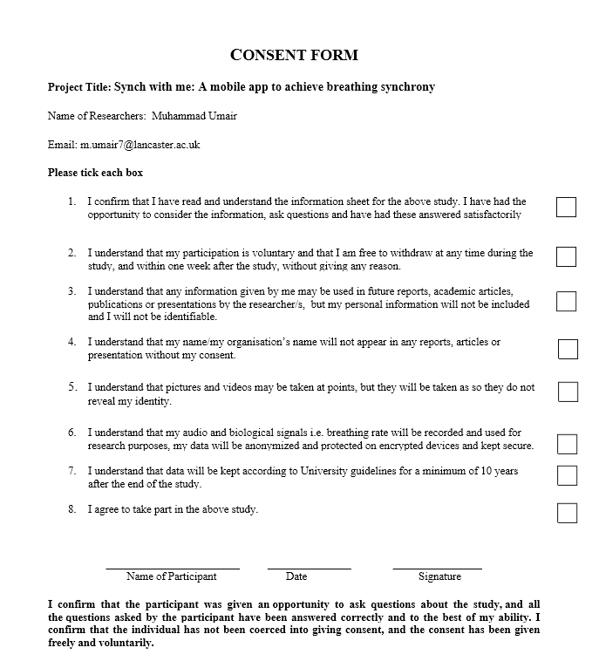


Appendix 4. User study interview questions

Initial interview questions
Overall Experience: During Activity
- How would you describe the experience during the activity? Please Explain?
- What would be some words you use to describe this experience? Why?
- Do you think it was easy to breathe together? Please Explain? How/Why?

Overall Experience: After Activity
- How did you feel after the activity?
- Do you think the activity was beneficial in any way? Please Explain, How and Why?
- Did you experience anything during your participation that you didn’t initially expect?

App feedback
- Did you use anything similar before? If yes, what does it do?
- Did you ever engaged in breathing together with anyone? If yes, how was the experience?
- What do you think about the breathing feedback in the app? Was the feedback helpful in guiding your breathing together? (Were you able to breathe with the feedback – expanding/contracting circle)
- If any? what improvements, you think could be made?

Overall Picture of the Project:
- Do you see any benefit of doing this activity together compared to when you are doing this remotely in separate locations? How/Why?
- Do you think you learn/gained anything from performing this activity together?
- If you were given access to the application how often/long would you use it?
- What makes you feel that way?

Second interview questions
Overall Experience: After Activity
- How long did you end up using the app over the 3-day period and how was your overall experience with it?

- Do you think the activity was beneficial in any way? Please Explain, How and Why?

- Did you experience anything during your participation that you didn’t initially expect?

App feedback
- If any? what improvements, you think could be made?

Overall Picture of the Project:
- How long did you end up using the app over the 3-day period?

Appendix 5. User study poster



